**State the name of the Company**: Tennessee Education Lottery Corporation

**What business is it in**: Tennessee State lottery / State of Tennessee department

**What year the annual report is for**: Annual Audit Report for year ended June 30, 2016

**Source**: <http://www.tnlottery.com/aboutus/reports.aspx>

**Source**: http://www.tnlottery.com/aboutus/media/2016_Financial_and_Compliance_Audit_Report.pdf



**Balance Sheet Statement used from source:**

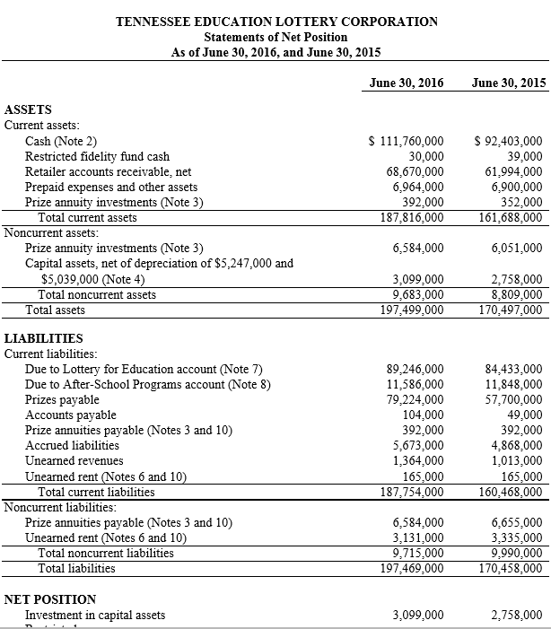

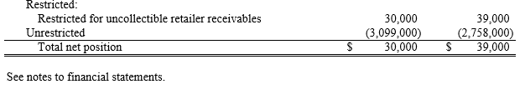

**Income Statement used from source:**

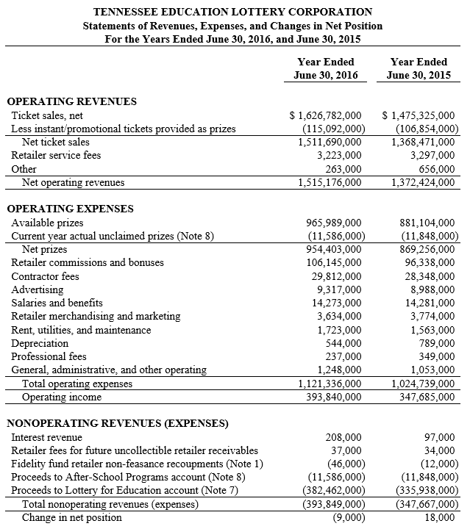

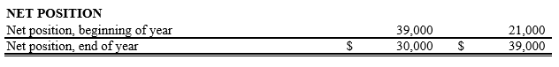

Note that the below statement has a type-o, the first column should be June 30, 2016.

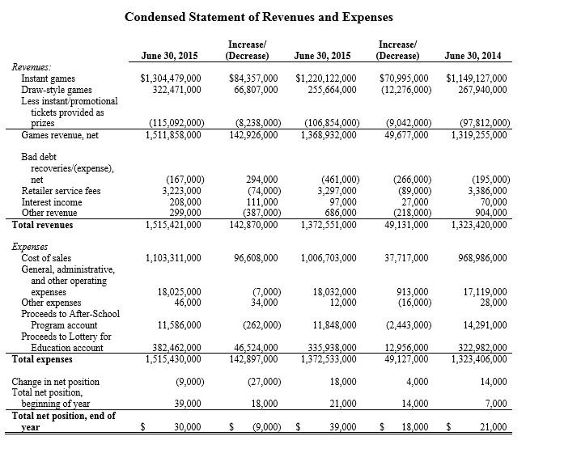

**Statement of Cash Flows statement used**:

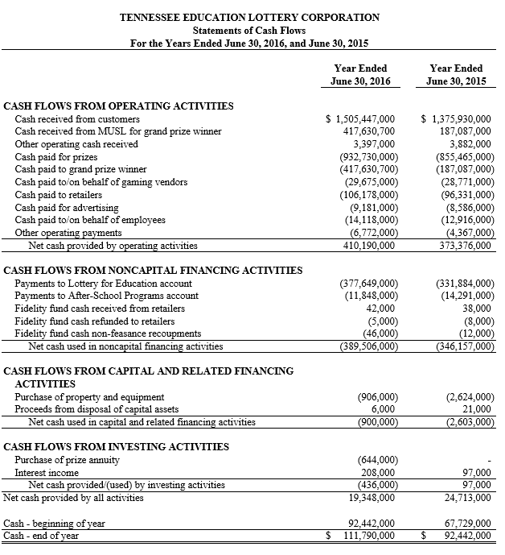

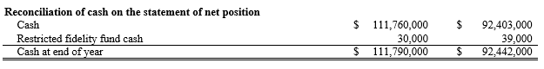

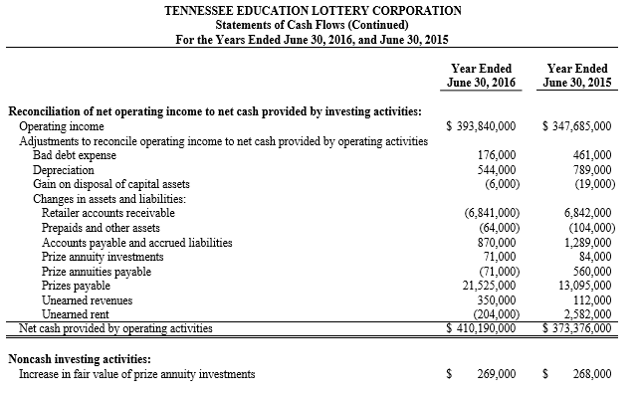

Profitability Ratios:

Assumption:

Net Income, can be gain from Income statement:

Net Income (or Net loss) =Revenues- Expenses

Total Revenue=Net Operating Revenues+ Total Nonoperating Expenses

Total Revenue=1,515,176,000+393,849,000=1,909,025,000

Total Expense= Total Operating Expenses

Total Expense= 1,121,336,000

Net Income =1,909,025,000-1,121,336,000=787,689,000

Total Assets, Shareholders’ Equity, Total liabilities can be gain from the balance sheet

* + **Return on Assets (ROA)** =Net Income / Total Assets =

$787,689,000 / $197,499,000=$ 3.988318928 or roughly $3.98

**Explain**:

The company earns a profit level (roughly) 4x its resources. It can derive roughly $4 dollars of earnings from each dollar of its assets. This is a good ROA.

* + Return on Equity (ROE) = Net Income / Shareholders’ Equity:

*Assumption*:

Because of the business type, shareholder’s Equity can be = “Invested in capital asset” +” Restricted for uncollectible retail receivable” (both values can be found on the balance sheet).:

Shareholder’s Equity=$3,099,000+$30,000=$3,129,000

So, **ROE**= $787,689,000 / ($3,129,000) = 251.738255

**Explain**:

This company has a high return on equity for its shareholders (which is really the state of TN). The money being invested into this company is creating a profit.

* + Profit Margin = Net Income / Net Sales

*Assumption:*

Net Sales = Gross sales – sales returns-Allowances -discounts

For this kind of business, we can consider Net Sales to equal Net ticket sales+ Retailer Service fees+ other (all found under operating revenues on the income statement)

Net Ticket Sales=$ 1,511,690,000

Retailer Services Fees=$ 3,223,000

Other= $263,000

Net sales= $ 1,511,690,000+$ 3,223,000+$263,000=$1,515,176,000

Profit Margin=Net Income / (Net Ticket Sales+ Retailer Services Fees+ Other)

**Profit Margin**= $787,689,000/($1,511,690,000+$3,223,000+$263,000)=0.519866339 or roughly 51.98%

**Explain:**

A profit margin of 51.98% is very high. Assuming, that past profit margins have been lower, this would suggest a greater willingness for customers to buy said products.

Activity Ratios:

*Assumption*:

Net sales= $ 1,511,690,000+$ 3,223,000+$263,000=$1,515,176,000

Average Day’s Sales= Net sales / 365= $1,515,176,000/365 = $4,151,167.12

* + Days Receivables Outstanding = Accounts Receivable / Average Day’s Sales

*Assumption:*

-Accounts Receivable can be found on the balance sheet-

Accounts Receivable= Retailer Accounts Receivable =$ 68,670,000

**Days Receivables Outstanding**= $68,670,000 /$4,151,167.12 = 16.54 days

**Explain:**

16.54 days is a healthy low value for average collection time on sales. It does not take long for this company to collect its profits.

* + Inventory Turnover = Cost of Goods Sold /Average Inventory

*Assumption:*

Using the Condensed Statement of Revenues and Expenses, we found the cost of goods sold= $1,103,311,000

We can take capital assets to equal inventory. So, June 30, 2016 ending inventory = $9683,000; June 30, 2015 beginning inventory = $ 8,809,000

Average Inventory= ($9,683,000+$ 8,809,000)/2 =$9,246,000

**Inventory Turnover**= $1,103,311,000/$9,246,000= 119.3284664

**Explain**:

The company has a good inventory turnover ratio. The company turns over inventory (roughly) 119 times a year.

Solvency Ratios:

* + Current Ratio = Current Assets / Current Liabilities

*Assumption*:

Current Assets= $187,816,000

Current Liabilities= $187,754,000

**Current Ratio**= $187,816,000/$187,754,000=$1.00

**Explain:**

This ratio is great, since the company has a constant inflow of money.

* + Acid-Test Ratio = Quick Assets /Current Liabilities

*Assumption*:

Quick Assets= Cash+ Marketable Security + Accounts Receivable

Accounts Receivable=$68,670,000

Cash=$111,760,000

There wasn’t detail information given about marketable securities, so I just used Cash and Accounts Receivable in my calculation. Marketable securities can be debatable (items that can be quickly sold under a year).

**Acid-Test Ratio**= ($68,670,000+$111,760,000)/ $187,754,000=0.9609915102

**Explain:**

This ratio suggests that the company may have issues paying their short-term debt. Although, I find it hard to believe that they don’t have marketable securities, so the ratio is likely to be at or above 1. This would imply that they can pay off short-term debt.

0.96 is less than 1

An acid-test ratio equal or greater than one would suggest the ability to pay off short-term debt.

* + Debt Ratio= Total Liabilities / Total Assets

Total liabilities=$197,469,000

Total Assets=$197,499,000

**Debt Ratio**= $197,469,000/$197,499,000=0.9998481005

**Explain:**

This company has a high debt ratio, so it is highly leverage. Returns on actual investments will be higher for the owners (TN State Department).

* + Debt-to-Equity Ratio= Total Liabilities / Owners’ Equity

*Assumption*:

Given the nature of this business, we will take our Shareholder’s Equity value to be equal to Owner’s Equity=$3,129,000

**Debt – to- Equity Ratio** =$197,469,000/$3,129,000=66.1093001

**Explain:**

This value shows that the company has a high level of debt. Ideally, this can create more profit for the business. This makes sense, because of the nature of the company.

* **Based on your review, would you judge the financial state of the company as healthy or unhealthy?** From my point of view, this company is very healthy, but it may have issues.

**Why?**

1. Its return on assets is good, profit levels (roughly) 4x its resources.
2. Its return on equity is good, with a ratio of 251.738255.
3. A profit margin of 51.98% is good, assuming it was lower in the past.
4. Its inventory turnover rate is high.
5. It has a lot of debt, but it’s ideal for this kind of business (maybe). The Acid-test ratio makes me wonder if there is an issue. Usually, a ratio of at least 1 is good. Its always best when you know the company has a strong ability to pay off its debts.

*** This is not an official Review, Just me practicing pulling and reviewing business data. If you’re looking for financial help, go to your local accountant. ***